Purchasing Analysis:

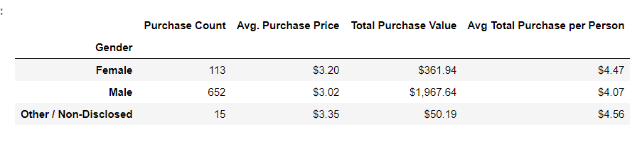

Purchasing Analysis (Age)

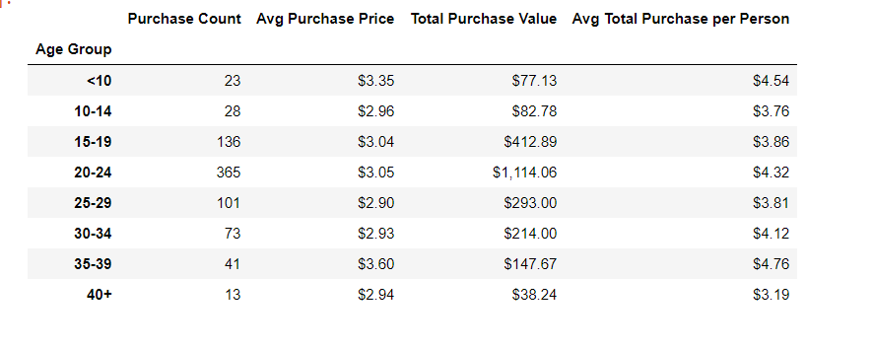

Top Spenders:

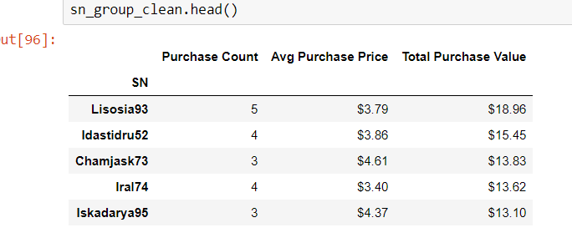

Most Popular Items:

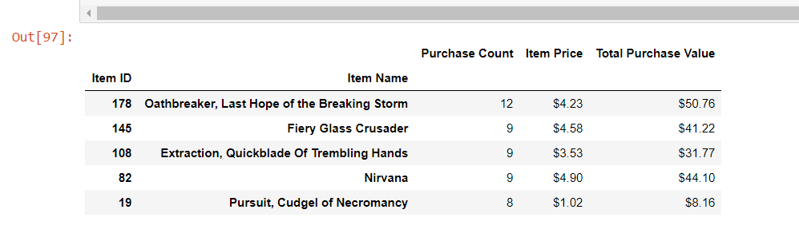

Most Profitable Items:

